# Problem #2: Detection of a Pulse at Unknown Time Offset

We receive a pulse of the form:

$$x=\left\{\begin{aligned}A\cos{2πf(t-t_{0})}+n(t) \\ n(t)\end{aligned}\right. {t_{0}<t<t_{0}+T \atop else}$$

1. Define the optimal detector here.

$$γ\left(Τ\right)=r\left(Τ\right)∙\hat{s}$$

$$\max\left(γ\left(Τ\right)\right){}_{<}^{>}{ threshold}$$

By looping over different values of Tau, we can correlate across different values, and select the maximum value from all the convolutions. If this value is greater than a known threshold, then our signal has been detected.

1. What is the minimum SNR for detecting the pulse? Why?

The minimum SNR for detecting the pulse is -18dB. This is determined by calculating $N\frac{A_{0}^{2}}{σ^{2}}{}_{<}^{>}{threshold}$

For a given N and a given threshold.

1. See Appendix 5.1 for source code.
2. 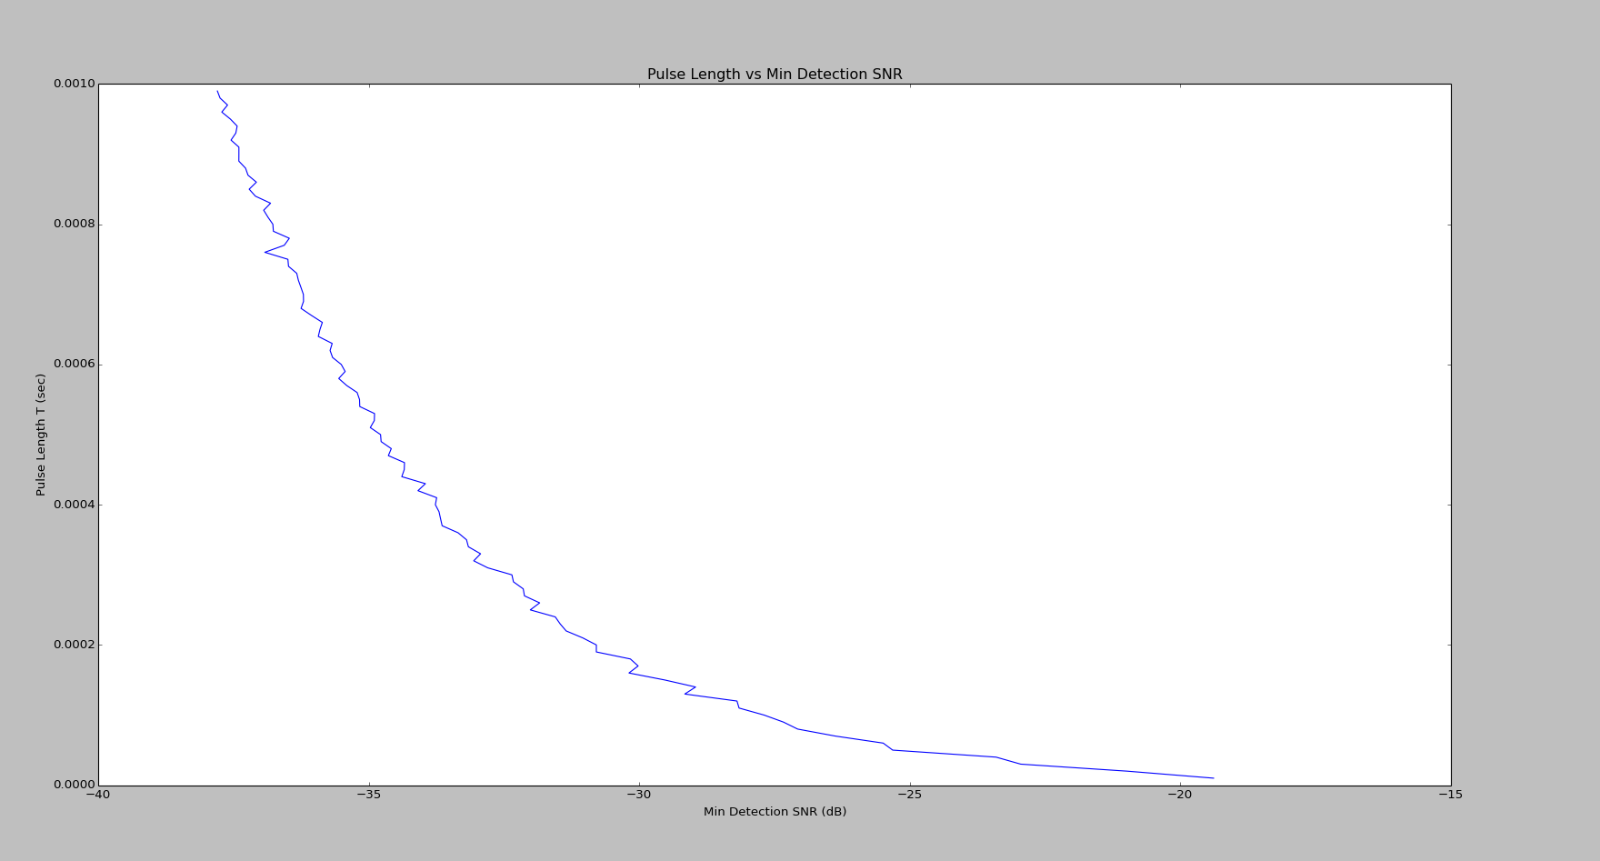Plot the minimum detection SNR vs. pulse length T.

We can see the minimum detection SNR increases as the sample length decreases (fewer samples), as we would expect.

# Problem #3: Detection of a Pulse at Unknown Time and Frequency Offsets

We receive a different pulse, of the form:

$$x=\left\{\begin{aligned}A\cos{2πf(t-t_{0})}+n(t) \\ n(t)\end{aligned}\right. {t_{0}<t<t_{0}+T \atop else}$$

Where $f_{1}<f<f_{2}$.

1. Define an optimal detector.

$$γ\left(f, Τ\right)=r\left(f,Τ\right)∙\hat{s}$$

$$\max\left(γ\left(f,Τ\right)\right){}_{<}^{>}{ threshold}$$

By looping over different values of frequency and Tau, we can correlate across different values, and select the maximum value from all the convolutions. If this value is greater than a known threshold, then our signal has been detected. This is the optimal detector because we can detect regardless of frequency and time offset.

1. What is the minimum SNR for detecting the pulse. Why?

The minimum detection SNR is -18dB. This is determined by calculating

$N\frac{A_{0}^{2}}{σ^{2}}{}_{<}^{>}{threshold}$

For a given N and a given threshold.

1. See appendix 5.2 for source code.
2. 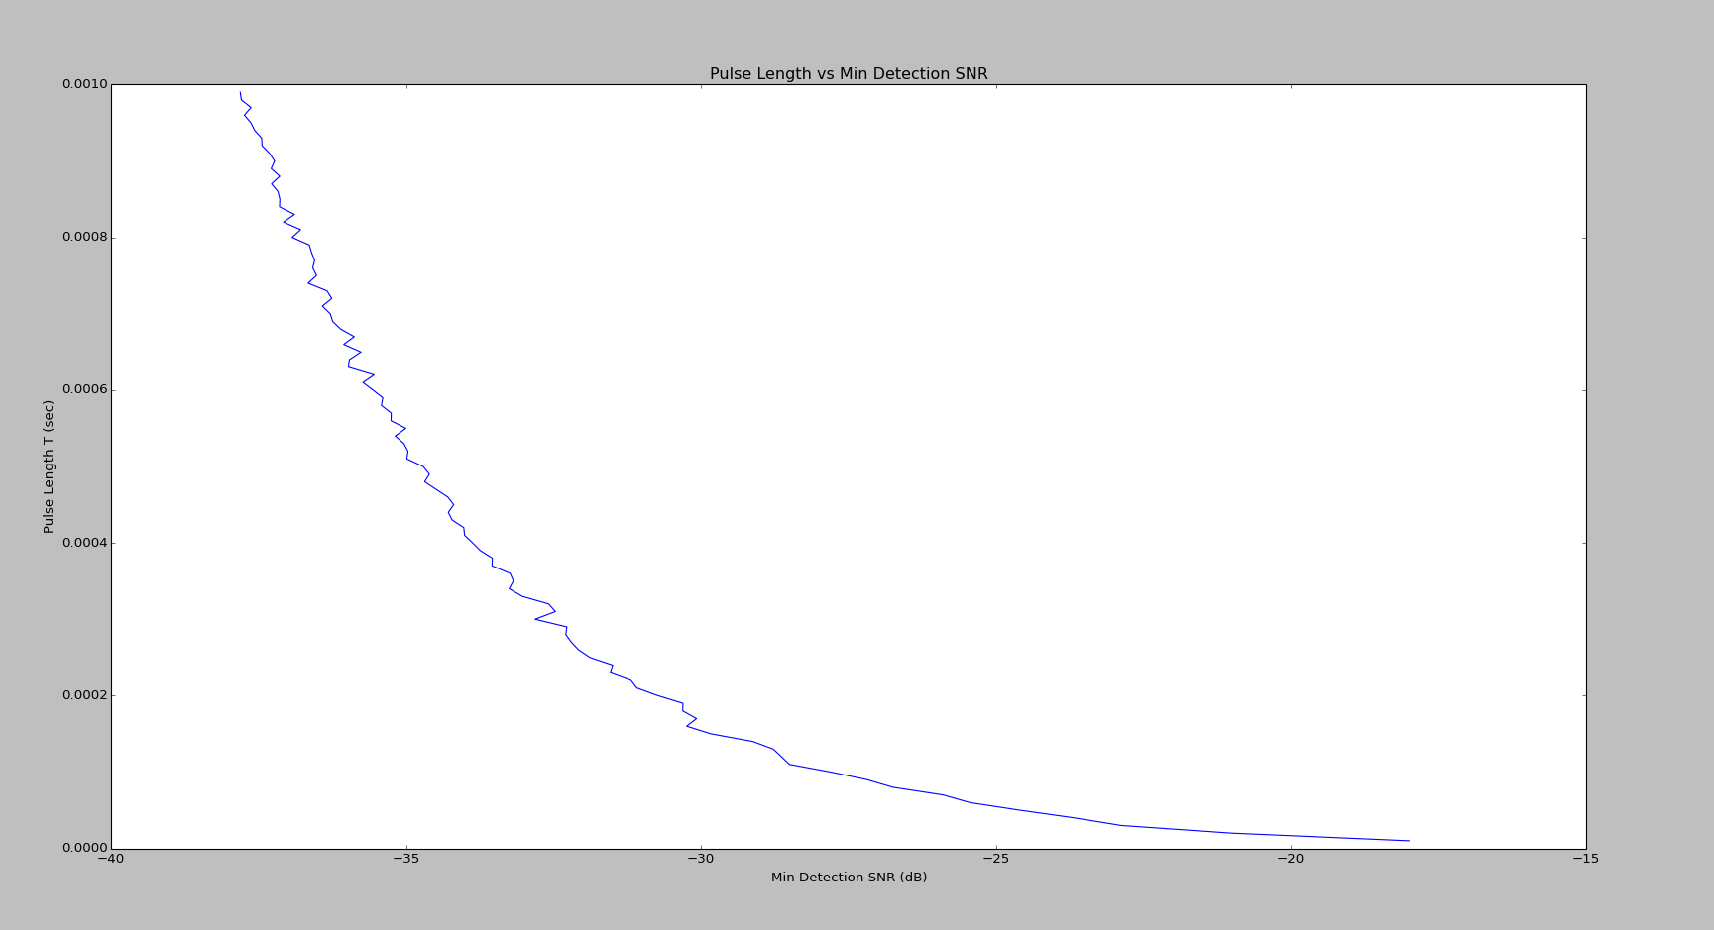Plot the minimum detection SNR vs pulse length, T
3. What happens as frequency slowly drifts over time?

If the frequency drifts over time, we can still detect it as long as it drifts within the range we correlate against. If it is known that the frequency drift among a large range of frequencies, we can correlate against many different frequencies in order to ensure detection.